**Chapter 3**

**3. Requirements Gathering & Analysis**

The Software Development Life Cycle (SDLC) is an organized procedure that makes it feasible to produce software that is both affordable and of excellent quality in the quickest amount of time. Producing exceptional software that meets and beyond all client expectations and requests is the aim of the SDLC. The Software Development Life Cycle (SDLC) is a comprehensive plan consisting of stages, or phases, that cover distinct processes and outputs. Following the SDLC reduces project risks and expenses related to using alternative production processes while also accelerating development.

* The importance of SDLS:
* Improved transparency of the development process for all concerned parties.
* Effective scheduling, planning, and estimating.
* Enhanced cost estimation and risk management.
* Streamlined software delivery and increased client satisfaction.

# 3.1 Methodology Used (SDLC model)

* How an SDLC works has several stages:

Planning: Developers and stakeholders collaborate to establish the project's goals, schedule, resources, and scope at this phase. It resembles drawing out a roadmap for the complete process of developing software.

Analysis: After the strategy is established, the analysis phase begins. Developers examine the software's needs in great detail at this point.

Design: When the needs are well understood, the design phase is similar to drawing a building's blueprint. The software architecture is meticulously planned by developers, including the interactions between various components.

Coding, or implementation, entails writing code, integrating various modules, and making sure the programmer operates as intended.

Testing: To find and address errors or problems in the software, developers thoroughly assess it at this phase. Testing guarantees that the programmer satisfies user expectations and operates as intended.

Deployment (and Maintenance): The software is prepared for deployment when it has passed testing. Users can download the software, and developers keep an eye on its functionality. In addition, any problems that crop up after deployment are taken care of by regular maintenance. This stage makes that the programmer stays functional and adjusts to new developments in technology or user requirements.

**3.1.3Advantages and disadvantages of SDLC:**

* The advantages of SDLC:

The Software Development Life Cycle (SDLC) provides developers with an effective planning and task organization system as well as an organized approach to software development. This methodical approach reduces errors and increases efficiency while guaranteeing the timely delivery of high-caliber software.

Risk management: One of the SDLC's best features is its capacity to recognize and control hazards that are present throughout the software development life cycle. Developers can reduce the overall risk involved in software development by proactively addressing and mitigating any risks as soon as they are identified.

Consistency: The standardized framework and methodology of the Software Development Life Cycle (SDLC) creates a basis for software development consistency. This consistency plays a key role in improving the software's quality and ensuring that the finished result flawlessly meets customer expectations.

Collaboration: By giving team members a uniform application architecture and language for communication, the SDLC promotes a collaborative atmosphere. This cooperative synergy guarantees that the final result perfectly satisfies the client's needs in addition to improving the software's overall quality.

Cost-Effective: By using prototyping tools like Sigma and others to uncover possible problems early in the development process, the SDLC shows itself to be a cost-effective methodology.

* The disadvantages of SDLC:

Time-consuming: Getting around the SDLC takes a lot of time, especially when complex development procedures are involved. This is one of the main drawbacks. This time commitment may result in annoying software delivery delays that affect clients and developers equally.

Strict framework: The SDLC shows some rigidity, especially when dealing with project requirements that change during development. This inability to adapt may result in a finished product that is unable to satisfy the client's evolving requirements.

High Upfront Cost: Investing a significant amount of time, money, and resources up front is necessary when starting an SDLC project. This initial outlay might be a significant barrier for startups or smaller companies that do not have the resources to dedicate to the SDLC's requirements.  
Overemphasis on Process: The SDLC may have the drawback of emphasizing the development process too much, which could overshadow the final product. This overemphasis could unintentionally hinder creativity and innovation, producing a finished product devoid of the spark of uniqueness and inventiveness.

Methodology example in project:

1. Waterfall methodology

Of all the project management techniques on our list, this one could be the easiest to understand and follow, as well as the most conventional. The project phase’s flow downward using the waterfall methodology, hence the name makes sense.

When to use it?

The waterfall method works well for highly organized projects like manufacturing and construction, especially when it would be too costly to make changes after the fact. Gantt charts are used in the waterfall approach for scheduling and planning.

1. Agile methodology

Agile project management is a collaborative, dynamic approach to team self-organization. Project planning and task management are flexible, evolutionary in development, pursuing early delivery, and always open to change if it results in process improvement when using the agile methodology.

When to use it?

Is agile the right fit for you? It has been used for non-software products like computers, cars, medical equipment, food, clothes, music, and more that aim to advance innovation and contain some degree of uncertainty. It is also employed in other kinds of projects where a quicker and more flexible production schedule is required.

1. Scrum methodology

Scrum methodology is a quick "sprint" method of project management. The scrum process is It works best for teams with no more than ten members, and it's frequently used with two-week cycles that include quick daily sessions called "daily scrum meetings." It is overseen by a person known as a scrum master. Scrum is used in an agile project management framework, though it has been scaled up to work in larger companies.

When to use it?

Though its supporters point out that the scrum methodology can be used to any industry or organization, including retail logistics, event planning, or any project requiring some flexibility, it has primarily been utilized in software development.

* 1. **Tools for Data gathering**

**Introduction:**

Collecting data in a home maintenance service is a vital process of understanding customer needs and providing outstanding service. Data collection includes customers’ personal information, details of issues they encounter at home, their best maintenance dates and times, and any other preferences they may have. And data collection is important role during the phases of development Future maintenance process, for home maintenance services as it aided in understanding the needs and desires of prospective clients. This segment outlines the methods employed to gather user specifications from both employees and customers of ‏home maintenance services.

**Why Gather Data?**

One crucial phase, in the development process involves gathering data s using insights from users. helps improve customer experience, and better identify recurring problems that need improvement analysis maintenance patterns and anticipate potential failures, helping to submission service quality more effectively to planning and scheduling processes and make recommendations to customers on preventive maintenance and future improvements .and appropriate training to improve their efficiency. to providing better and more customer-satisfising maintenance service.

**Tools for Data Collection:**

To effectively gather user requirements a range of tools were utilized, including surveys and interviews. These methods offer advantages for collecting data from user segments encompassing both qualitative and quantitative aspects (Merriam & Tisdell 2016). During the data collection process past tense is employed to describe completed actions, like conducting interviews and administering surveys. The purpose of gathering data is outlined along with details, about the techniques and participants chosen all in the tense.

1. **Description of Tools:**

**Questionnaires:** As mentioned by Merriam and Tisdell (2016) questionnaires are structured tools used to gather data through a series of predetermined questions provided to participants. They offer advantages, such, as speed and the ability to quickly collect information from a group of people. Additionally, the anonymity provided by questionnaires can encourage participants to provide feedback without fear of judgment.

**Interviews:** In order to delve into insights in depth researchers and participants engage in face, to face or conversations during interviews (Merriam & Tisdell 2016). Unlike surveys interviews allow for clarification and follow up discussions helping researchers gain an understanding of the perspectives and experiences of respondents. This method encourages responses that uncover nuances not easily captured through surveys alone.

**Justification of Tool Choice:**

The decision to use questionnaires and interviews, for this project was based on their strengths and appropriateness for capturing a variety of perspectives. Questionnaires were chosen as they offered a means to gather data efficiently and solicit feedback from a large group of participants including customers and staff at ‏home maintenance services.

On the hand interviews were included to complement survey findings by delving into users’ preferences and experiences. By engaging in ended conversations during interviews the project team could explore nuanced aspects of customer needs that may not have surfaced through survey questions alone. By combining both surveys and interviews the project team ensured an understanding of customer requirements ultimately enhancing the development process of the app, for home maintenance services.

1. **Applying Tools to the Project:**

**Aim of the Questionnaire:**

The questionnaire aimed to gather insights, on the features desired by customers The project team collected input directly from both ‏home maintenance services staff members and consumers to identify enhancements that would enhance the apps user friendliness and appeal. information to understand the needs and preferences customer to improve the services or products offered.

**Respondents:**

The survey targeted two groups; employees of ‏home maintenance services and its customers. A total of 61 participants consisting of eleven staff members and fifty customers were invited to share their opinions and preferences regarding the features of the Smart Cart app. By incorporating feedback, from both staff and external clients a comprehensive understanding of user needs was achieved, incorporating perspectives from those involved in the home’s operations well as those utilizing its services.

**Administration of the Survey:**

Google Forms was utilized for carrying out the survey to simplify the process of gathering data. This platform offered advantages, including data consolidation accessibility, on various devices and ease of distribution. Participants were sent a questionnaire link via email or other communication channels so they could respond at their convenience. By leveraging a survey tool not was the data collection process streamlined but also enabled better organization and analysis of responses.

By opting for Google Forms to administer the survey the project team aimed to provide respondents with a user effective data collection experience. This approach contributed to achieving response rates and reducing burdens (Dillman, Smyth, & Christian, 2014). Through this method detailed feedback was gathered from both ‏home maintenance services staff members and consumers shaping the development to align with user preferences and expectations.

**3.3 Data Analysis & Findings**

**3.4. Data/ Process Modelling**

Data modelling involves creating a visual representation of data structures within a company or organization. This process helps in understanding how data is organized, stored and used. Data modelling involves defining entities, attributes, relationships, and constraints to ensure data integrity and efficiency in database design. It plays a critical role in developing databases that meet the specific needs of a project or business. (*What Is Data Modeling? | IBM*, n.d.)

**3.4.1 Use Case Diagram:**

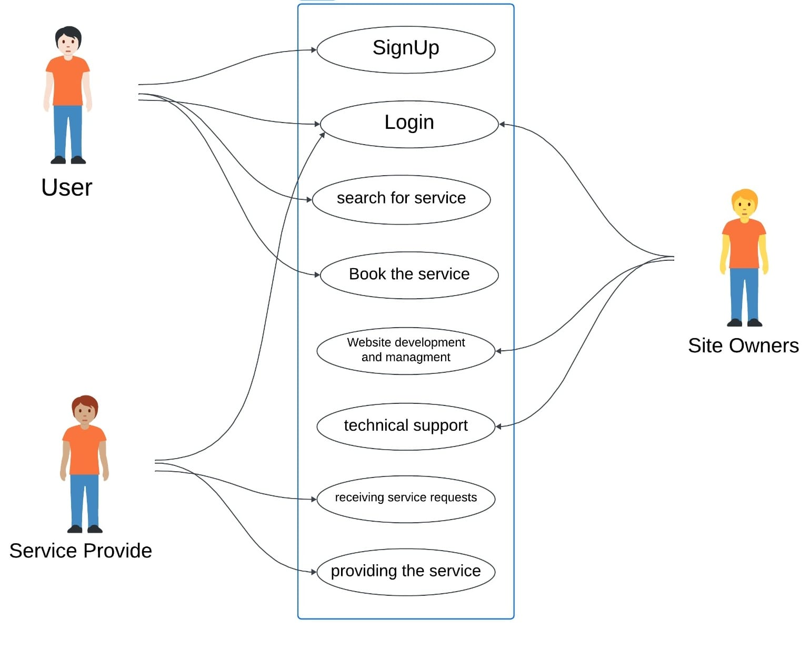

* + 1. 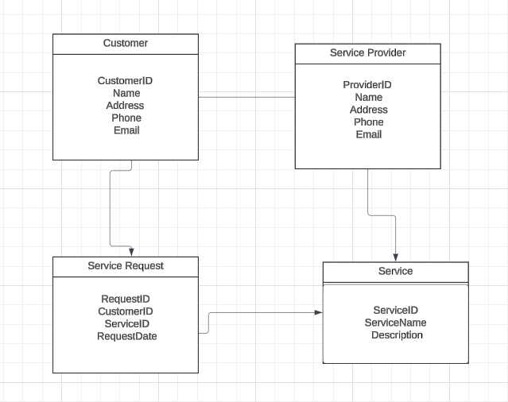**Entity Relationship Diagram:**
    2. **Context Diagram:**

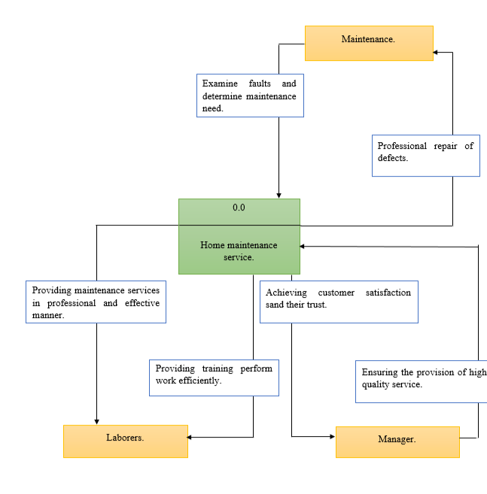

* + 1. **Level 0 DFD:**

**3.4.5 Level 1 DFD:**

**3.4.6** **Storyboard:**

**3.5 Technical Requirements**

* Software requirements used in the project

|  |  |  |  |
| --- | --- | --- | --- |
| NM | Software name | Application | Description |
| 1 | Visual Studio | Figure 1:Visual Studio | * We used this program to design the website. It is a program that edits codes, detects errors, and supports all languages. |
| 2 | Microsoft Word | Figure 2: Microsoft Word | * Complete all project tasks and assemble it. * Complete the report. |
| 3 | Project liber | Figure 3: Project libre | * Use this application to complete work in breakdown structure and Gantt chart |
| 4 | Canva | Figure 4: Canva | * We used Canva to design and draw some diagrams, such as the Methodology (SDLC model). |

* Hardware requirements used in the project

|  |  |  |  |
| --- | --- | --- | --- |
| NM | Software name | Item’s Picture | Description |
| 1 | Laptop | Figure 1: Laptop | We used the laptop to complete the project. |
| 2 | phone | Figure 2: phone | Using the phone to communicate with group members on WhatsApp or any other program to transfer information and discuss it with each other. |
| 3 | USB | Figure 3: USP | Used to saved project information. |
| 4 | print | Figure 4: print | We used printing to print some tasks in this project, as well as to print the poster, and finally to print this project when it is finished. |

**3.6. Literature Review:**